**Tableau – R connection**

**Step 1**: Open R studio and run the following commands:

install.packages("Rserve")

library("Rserve")

Rserve()

**Step 2**: Open tableau and goto-> Help->Settings and Performance-> Manage External Service Connection

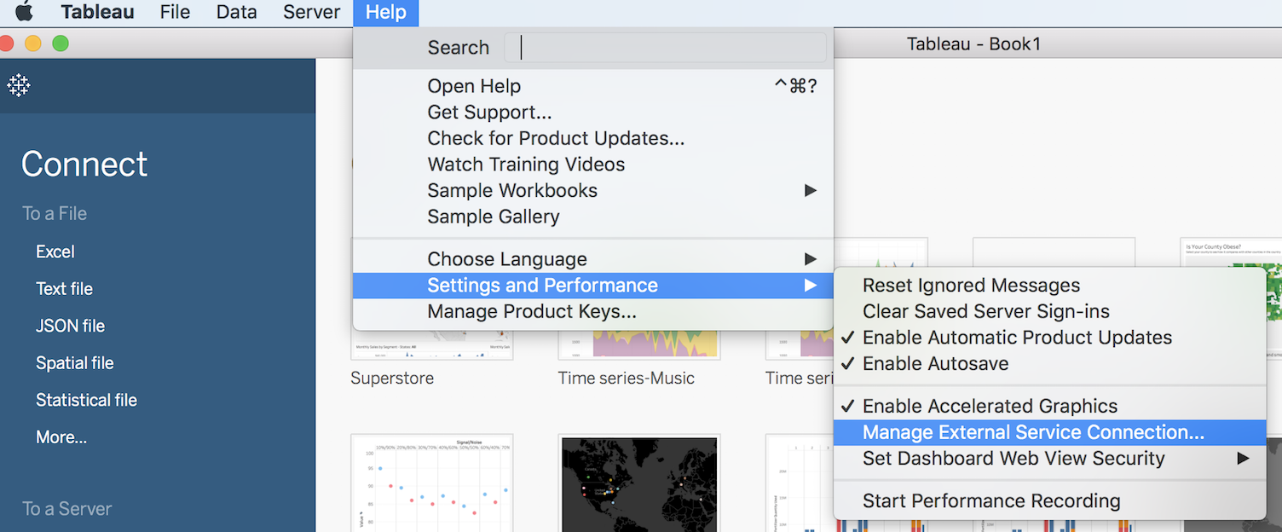

**Step 3**: Give Server as localhost and port as 6311. Then, Test connection.

